#29

Picture this, you are at home writing a term paper and when you get to an article you can use for it, you keep reading the same paragraph over and over again before you get distracted by an ad for Amazon with a shirt you like or an ad for a movie you are really wanting to see. With the rise of the internet came the rise of many wonderful things but it also came with a whole lot of distractions. In the chapter, “Minds Wander 30 Percent of the Time”, the book talks about how it is both a good thing and a bad thing that when we get distracted, which is 30% of the time for majority of people, it is because we are “doing one task and then fading into thinking about something unrelated to the task” (Weinschenk & Ph.D., n.d.). To put it bluntly, our brain is a toddler who is looking at something shiny when we need it to look at this dull object we need to focus and study on once again this is 30% of the time sometimes 70% of the time. I think this relates to web design because of the example I used before. When we are surfing the web or doing anything kinda dull, if there is an ad that we like we will either click on it or divert our attention to googling tickets to get the movie tickets or searching for that shirt for minutes to hours on Amazon especially if there is a whole lot of ads. According to the article *Attention merchants: How advertising* distracts us by Business Insider, they mention a quote by author of Tim Wu, “’The web model, which is all about attentional extraction at any cost, leads to a design of a web that's almost like a casino," Wu said. "You want people constantly clicking away, lost in vortexes’” (*Attention merchants: How advertising distracts us*). This doesn’t help that we are having constant distractions while we are working or just browsing the web. And this is where this all relates to web design. You see it isn’t just the advertisers who are to blame for us being distracted by ads, it’s the designers. We understand that websites are now monetized by company’s to help get their name out there but the volume of ads is getting ridiculous. Even when I was reading the article mentioned above there were 3 ads and a recommended video that was presented to me. 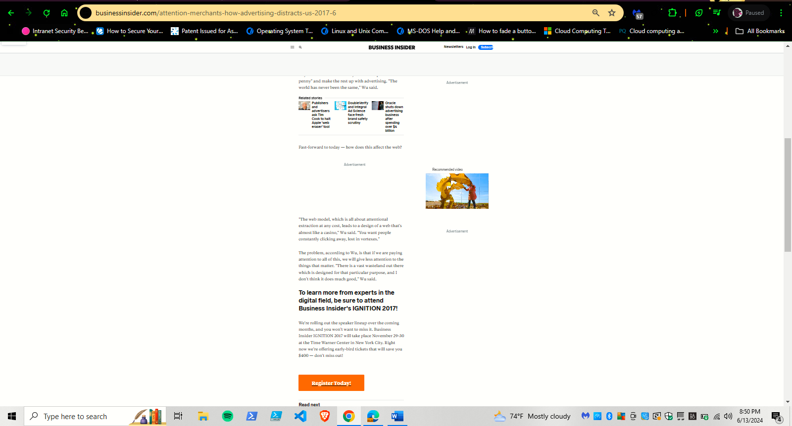

This can be good since it is a way to give the brain a mini break but there is a point where it can become too much. For a website like Citation Machine they use all the different positioning for ads and it can get annoying. A screenshot of a computer

I think giving our brain a mini break is amazing but it has to be done in moderation. Here is an article on how to position ads and I personally think having the ads in one position is enough to get the point across:

<https://adsinteractive.com/blog/where-to-place-ads-on-your-website/>

#33

In the chapter, “people Process information best in Story Form” it states “stories may create causation when none is there. Because stories usually involve some form of chronological narrative . . .they imply causation even if none is there”( Weinschenk & Ph.D., n.d.). A extremely easy example or examples of this is the “about”, “mission” or even full bio websites. People like to learn and process information about people or things they find interesting and in a way it forms some trust. Here is a website I found that has an amazing example of this:

<https://www.peachandlily.com/pages/about-p-and-l>

This is a South Korean skin care brand called Peach and Lily. Now if you don’t know, South Korea is up there when it comes to the best skin care in the world. What is awesome about this brand is they state in their about page they are “sustainable”, made for “sensitive skin”, are “toxin-free, vegan, gluten-free, and fragrance free” (Peach and lily). This company has a vision to help people obtain the “glass skin” that k-pop artists have and being all the things mentioned before along with it.

Citations:

Business Insider. (n.d.). *Attention merchants: How advertising distracts us*. Business Insider. https://www.businessinsider.com/attention-merchants-how-advertising-distracts-us-2017-6

Peach and lily. (n.d.). https://www.peachandlily.com/pages/about-p-and-l

Weinschenk, S. M., & Ph.D. (n.d.). 100 Things Every Designer Needs to Know About People. Retrieved from <https://platform.virdocs.com/read/1661285/40/#/4/2/2[ch29]/4,/1:0,/1:0>

Weinschenk, S. M., & Ph.D. (n.d.). 100 Things Every Designer Needs to Know About People. Retrieved from https://platform.virdocs.com/read/1661285/44/#/4/2/2[ch33]/4,/1:0,/1:0